West Coast Casualty’s
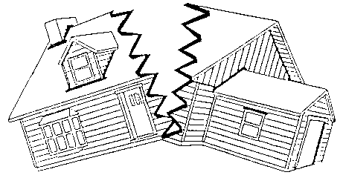

Construction Defect Seminar
May 9th and 10th, 2019
The Disneyland Resort Hotel
Anaheim, California, USA

Course/Topic Submission Form
You can easily fill in this form it as you go along as your topic submission for West Coat Casualty’s Construction Defect Seminar for 2019 and follow the easy directions below for submissions
Just don’t forget to “save” a copy of it for your own records.
(This form was created for a single submission topic - Please use additional forms for additional topic submissions)
Your name:
Your e-mail address:
Your proposed topic name: (You can change it in the future)
Your suggested co-presenters: (You can change them in the future)
An overview of the course: (You should include learning objectives)
Required for Insurance Department CE Credits:

What is the major item or discussion point? Time allocation: _____ (in minutes)

Describe here:

What are the sub item(s) of above: Time allocation: _____ (in minutes)

Describe here:

What are the sub item(s) of above: Time allocation: _____ (in minutes)

Describe here:
(Use additional space as needed)

Who is your target audience: (e.g. Experienced Attorneys and Intermediate Attorneys, Corporate Counsel, Adjusters, Claims and Risk Managers, etc.)
What is the educational level of this course: (e.g. entry level, intermediate, advanced)
Course Objective: (At the end of the course, what do you expect the participant will leave with?)
Can your topic can be considered for specialized continuing education accreditation: (i.e. ethics, diversity in the workplace, prevention of substance abuse, etc.)

Handouts/reading materials: (Some kind of handouts, reading materials, etc. is expected but you can submit PowerPoints, articles, materials produced by others (with their permission), et al. as your handout materials)
If you are including additional supporting documents you
MUST limit them to no more than 10 pages as that is our limit

Topics Due by Monday November 26, 2018

Your e-mail Address:

Submit at the following link: https://www.dropbox.com/request/zvNqS5T3FnKaIXuxVmon

